**Comprehensive-Analysis-and-Dietary-strategies-with-Tableau-A-college-Food-Choices-Case-Study**

**MENTOR: K.RATNA KUMARI MADAM**

**TEAM ID: LTVIP2025TMID52582**

**TEAM LEADER: VEERAMALLA HARI VENKATA PRASAD**

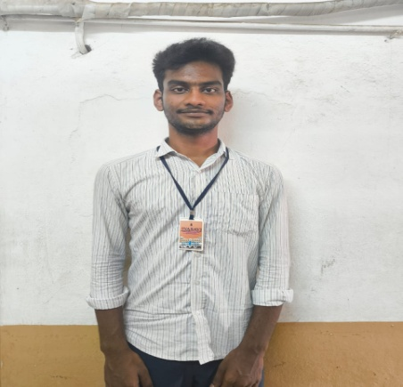**REG NO: SBAP0052582 MAIL ID:** [**hariveeramalla00@gmail.com**](mailto:hariveeramalla00@gmail.com)

**TEAM MEMBERS:**

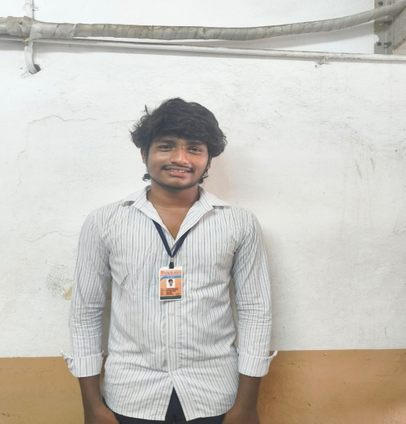**REG NO: SBAP0052589 MAIL ID:** [**anilpasupuleti74@gmail.com**](mailto:anilpasupuleti74@gmail.com)

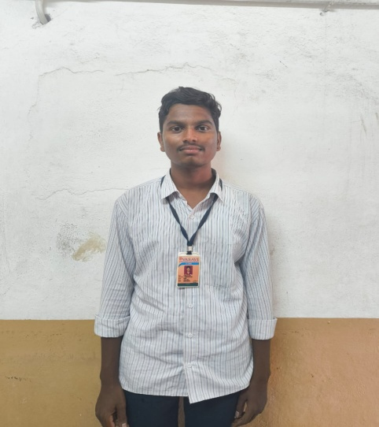**REG NO: SBAP0052643 MAIL ID:** [**rajeshrajeshyarra@gmail.com**](mailto:rajeshrajeshyarra@gmail.com)

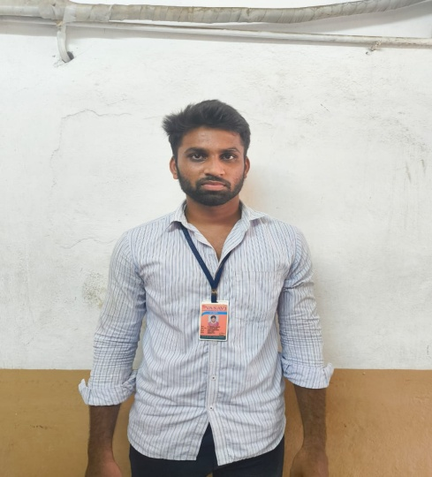**REG NO: SBAP0050921 MAIL ID:** [**krishnanani7714@gmail.com**](mailto:krishnanani7714@gmail.com)

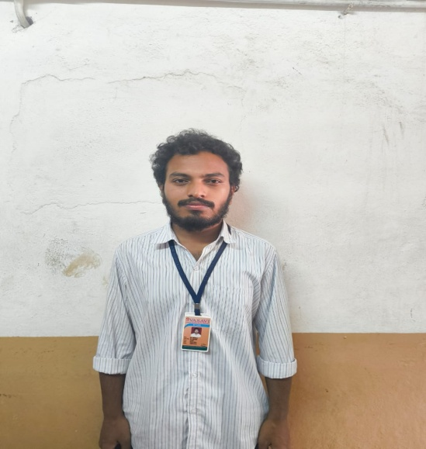**REG NO: SBAP0052616 MAIL ID:** [**sk0003118@gmail.com**](mailto:sk0003118@gmail.com)